HP48 to Mac Communication
Mark Power
A few years ago I took the plunge and bought my first home computer having previously borrowed various Windows machines. At work I’ve mostly developed on Unix systems and having tried video editing on a PC I decided that the way to go was Mac. Unfortunately the G5 PowerMac and all machines since don’t have serial ports so communicating with the HP48 is not immediately possible. So how do you get the two to talk to each other?

Hardware - USB Serial Adapter
Firstly you’ll need a USB to Serial Adapter. Searching the internet you’ll find lots of these but most of them only mention PC compatibility and I understand that many of these will not work because they don’t have the necessary drivers for Mac. The adapter I came across which works is the Keyspan USA-19HS.
In the UK this adapter is available from http://www.expansys.com for under £20. It comes with a CD-ROM containing drivers for Mac OS 8.6 and greater, and Mac OS X 10.2 or later. It’s worth mentioning that this adapter also works on Windows PCs and Linux if you have a modern PC without a serial port.

Software - Kermit
The next piece of the jigsaw is the communications software. HP49G+ and Mac owners can use HPConnect (available from hpcalc.org) with its nice interface but this doesn’t work with the HP48. Instead you’ll have to revert to opening the Terminal and running C-Kermit from the command line. If you’re not familiar with Terminal and Unix in general, start up Terminal then look in the Help menu.
The main Kermit site (http://www.columbia.edu/kermit/) has pre-built binaries for downloading but I found that getting the binary into the correct place wasn’t obvious and I encountered a problem with Panther because the binary wanted to use the /var/spool/lock directory and it is not created by default. If you encounter this problem when starting Kermit you’ll need to create the lock directory and set the appropriate permissions. This is obviously a common problem because Apple has a support article about it on their web site:
http://docs.info.apple.com/article.html?artnum=25676
Disliking the amount of messing about I was having to do I went searching for a simpler solution and came across Mac Ports which provides an infrastructure for building and installing open source software. I downloaded this from Darwin Ports (http://darwinports.com/). It has a standard graphical installer for the main package. Kermit is then installed within Terminal using the instructions at http://kermit.darwinports.com/. There are copious instructions for installing these packages but you may end up with slight differences in the directories like I did. I ended up with the “port” script and “kermit” executable located in /usr/local/bin.

Putting it together
When the adapter drivers are loaded and the serial adapter is plugged into the Mac it appears as a device called:
/dev/tty.USA19Hb2P1.1
Kermit is invoked from the command line by typing “kermit” and then entering a whole host of commands to get it to talk to the HP48 correctly. The commands are described on the Columbia University website at:
http://www.columbia.edu/kermit/hp48.html
There are rather a lot of setup commands to remember so you will probably find it easier if you enter them into an initialisation file. Open TextEdit, click “File”, “New” and then type in the following:

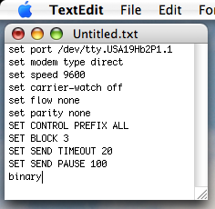
Click “File”, “Save as…”, select your home directory and enter the filename “.kermrc”. Ensure that you untick the option:

If no extension is provided, use “.txt”.

When you then click the Save button you will get a message saying that names that begin with a dot are reserved for the system. Click the Use “.” button. Alternatively if you have the appropriate skills go into Terminal and use vi to create .kermrc.
Ensure your HP48 is set to use wire (rather than IR), binary transfers, 9600 baud and no parity, then start server mode. With .kermrc saved you can then invoke Kermit at the Terminal command prompt. Assuming the drivers, Kermit and your initialisation file have all been loaded correctly you should see something like this:
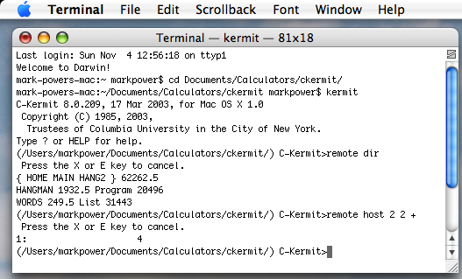

In this window I’ve changed to the directory where I store my HP48 files, invoked Kermit, got the contents of the directory on the HP48 (with the REMOTE DIR command) and performed some simple remote arithmetic using REMOTE HOST.
When transferring files they will end up in your current directory so you may want to create a directory on your Mac before you start and cd to that directory either before you start Kermit or at the Kermit prompt.
Rather than typing Kermit commands on the Mac you can put the Mac in server mode and issue commands from the HP48 for example ‘filename’ SEND and ‘filename’ GET. The Mac should display a screen like this with more details filled in when transfers are in progress:

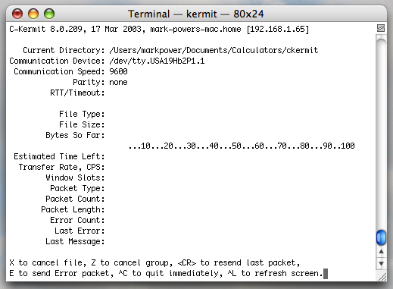

The initialisation script above sets transfers to binary, but you can change to ASCII transfers by typing “ascii” at the prompt and setting ASCII transfers in IOPAR on the HP48. Remember to set the translate option to the appropriate setting as well (3 is standard so that you don’t end up with HP48 specific characters on your Mac).
Within Kermit on the Mac typing a question mark at the prompt will show the available commands. You can then type another question mark having entered a command to see the options that can be specified. Lots more details about Kermit can be found on the Columbia University website. You may also want to look at Datafile V10N4P3 “HP Kermit Revealed” for a selection of commands from the HP48 that you can use that are not described in its documentation.

